**Q2.**

**Question Type: MCQ**

**Question Difficulty Level: Medium**

**Marking: (+2, -0.5)**

**Expected time to solve: 30 seconds**

**Topic: Basic Math**

**Concept: Profit and loss**

**Sub- Concept: cost price**

**Concept Field:**

Ali sold an article for Rs 24 which cost him Rs x. He finds that he has gained x%. find the value of x.

1. 30
2. 50
3. 20
4. 70

Answer: (C)

Solution:

Cost Price of the article is Rs x.

Selling price of the article

According to the question

So the value of

Q: If the coordinates of the ΔABC is A(1,3), B(5,7), C (3,2). Find the centroid of the triangle?

1. (3, 4)
2. (3, 6)

C) (2, 5)

D) (2, 7)

Answer: (A)

Solution:

We know the formula to find coordinate of centroid (x, y) of a triangle

So, The centroid of the triangle is (3, 4).

**Q10.**

**Question Type: MCQ**

**Question Difficulty Level: Medium**

**Marking: (+2, -0.5)**

**Expected time to solve: 30 seconds**

**Topic: Advance Math**

**Concept: Geometry**

**Sub- Concept: Triangle**

**Concept Field:**

Q: m,n are points on the sides PQ,PR respectively of a Δ PQR such that mn||QR and divides Δ PQR into two parts, equal in area ,find the ratio of MQ:PQ?

Answer: (A)

Solution:

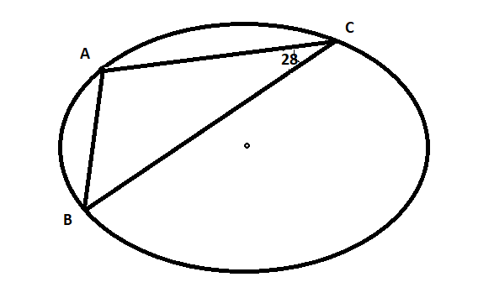**Q9.**

**Question Type: MCQ**

**Question Difficulty Level: Medium**

**Marking: (+2, -0.5)**

**Expected time to solve: 30 seconds**

**Topic: Advance Math**

**Concept: Cordinate Geometry**

**Sub- Concept: Position of point with respect to a line**

**Concept Field:**

Q: Find the value of m for which the lines 3x+2y-7=0 and 6y-mx-18=0 are perpendicular to each other.

1. m=4
2. m=-4
3. m=2
4. m=3

Answer: (A)

Solution:

By putting the formula of slope in eq. 1 we get,

By putting the formula of slope in eq. 2 we get,

Putting the value of M1 and M2 we get,

**Q7.**

**Question Type: MCQ**

**Question Difficulty Level: Medium**

**Marking: (+2, -0.5)**

**Expected time to solve: 30 seconds**

**Topic: Basic Math**

**Concept: Advanced math**

**Sub- Concept: coordinate geometry**

**Concept Field: position of a point with respect to line**

Q: RP is a straight line of 25 units. If R has the coordinates (2,8) and P has the coordinates (x,-12) find the value of x.

1. 17
2. -7
3. 16
4. 12

Answer: (A)

Solution:

We know the distance formula

So, x=17